|  |  |  |
| --- | --- | --- |
|  | RESEARCH PROPOSAL  Current Programme [e.g. PhD in Geography & Environmental Studies]  **TITLE OF STUDY** |  |
|  | FIRST NAME AND SURNAME (DEGREES ALREADY ATTAINED)  (STUDENT NUMBER IF APPLICABLE) |  |
|  | [Note: Much of the contents of this document was taken from the  Departmental Guidelines available from <https://goo.gl/Q1jB70> ]  [Document was last updated on 25 May 2017] |  |
|  | PROMOTOR/SUPERVISOR: TITLE, INITIALS AND SURNAME  Department of Geography & Environmental Studies  Stellenbosch University |  |
|  | CO-PROMOTOR/SUPERVISOR: TITLE, INITIALS AND SURNAME  Department  University |  |
|  | DATE OF SUBMISSION  DEPARTMENT OF GEOGRAPHY AND ENVIRONMENTAL STUDIES |  |
|  |  |  |

# BACKGROUND

“*Quote (optional).*” (reference)

Write a 1-2 page background to the study here. This part of the submission constitutes what Mouton (2001) calls the “world one” or “real-world” problem. [For instance, floods are one of the biggest natural disasters and can have devastating effects on life and infrastructure.] The background to the “real-world” problem should address at least the following aspects:

* Historical background to the problem [e.g. discuss some examples of flood events];
* The occurrence, nature and extent of real-world manifestations of problem events or elements [e.g. explain the impacts of floods];
* The source of motivation for the interest and/or involvement in the specific research theme by the researcher [e.g. recent geospatial technologies have the potential to improve flood modelling]; and
* The possible value of the research for increased knowledge [e.g. being able to predict where floods will occur will enable better mitigation strategies].

A thorough and in-depth identification and study of relevant sources of information are fundamental aspects of the compilation of a research proposal. Reference to these sources is essential. The latest research related to the specific topic should be briefly summarized here. [I.e. provide an overview of the traditional ways how floods have been modelled, with specific references to the literature (old and new). Specifically explain the state-of-the-art (most recent research) in the use of geospatial technologies for flood modelling.]

# PROBLEM STATEMENT

Normally this comprises the concise summary of all the problem elements that need to be addressed by the research. As such, this is what Mouton (2001) refers to as the “research problem”, or “world two” problem, and entails the identification of those problem elements that form the viable target of the research.

[I.e. flooding is a “real-world” problem, but it is not something that anyone can actually solve in a research project (i.e. it is not possible to stop floods from occurring!). Being able to accurately predict where floods will occur is closer to a research problem (because it is something that one can actually achieve), but it is still too broad because there are many ways of carrying out flood predictions (and you will probably not investigate them all). The research problem statement should outline the current gaps (unknowns) in the literature. For instance, a specific geospatial technique may show much potential, but has not been assessed for flood modelling. Or perhaps it has been assessed by other researchers (if so list them!), but not for a specific type of scenario.]

Ideally the research problem statement should culminate in one or more research questions.

[For instance:

*Which DEM derivatives are most important for modelling flooding?*

*How can DEM derivatives and machine learning be used to develop a flood hazard index?*]

Study aims and objectives flow logically from these questions.

# AIM(S) AND OBJECTIVES

The **research aim** is a concise, overarching statement that spells out what the researcher intends to produce during the research process. (Take note that this aim does not address the use that the researcher envisions the research results will be put to or the good to society that the researcher hopes will flow from it. This is what is commonly referred to as the purpose of the research and it is not uncommon for research reports to devote space – even a subsection – to specifying and explaining the purpose(s)). The aim focuses on concrete output the researcher wishes to produce as research products.

[For instance, “This study aims to develop a flood hazard map of the Western Cape using DEM derivatives and machine learning techniques”. In this example the flood hazard map is the research output.] This ‘product’ is mirrored in the individual objectives that are formulated. The formal aim statement serves to demarcate the study’s extent and focus [i.e. “using DEM derivatives and machine learning techniques”], and forms the gist of the “agreement” between researcher and supervisor or promotor of what is expected from the research.

**Research objectives** serve to deconstruct the aim and body of empirical research into its individual deliverable products. Each objective forms the focus of a specific research component or task to be performed at a given stage in the sequential research process and leads to the production of a separate research product. As such, each objective and its product eventually manifests as a significant part of the research report (something like a chapter or major part of one). Similar to the aim, the objectives serve to demarcate and discipline the research and the researcher’s activities to that which have been agreed to between researcher and supervisor or promotor.

To achieve the research aims, the following objectives have been set:

1. Objective 1. [e.g. “Carry out a literature review to identify the most appropriate DEM derivatives and machine learning techniques to use for modelling floods.” Here the literature review is a product, that will likely manifest into a section or chapter.]
2. Objective 2. [e.g. “Collect suitable data on flood occurrences that can be used to assess and train the machine learning algorithms.” Here the flood occurrence dataset is a product that will be described in a section or chapter.]
3. Objective 3. [e.g. “Derive a set of DEM derivatives that can be used as input to the machine learning algorithms.” Here the DEM derivatives is a product that will be described in a section or chapter.]
4. Objective 4. [e.g. “Carry out machine learning experiments in representative test site(s) to identify the best combination of variables and algorithms for producing an accurate flood hazard model.” Here the best combination of variables and algorithms are the research products.]
5. Objective 5. [e.g. “Implement the model hazard model identified in Objective 4 to produce a provincial flood hazard map.” The flood hazard map of the province is the research product.]
6. Objective 6. [e.g. “Quantitatively and qualitatively evaluate the flood hazard model and map.” The evaluation is in this instance the research product and will likely be the final chapter in the research report.]

Add more objectives as needed.

# SIGNIFICANCE AND RATIONALE

Provide rationale for carrying out this research. This is usually a concise summary of what has already been covered in the preceding sections, with a focus on why the specific aim and objectives are appropriate for addressing the real world and research problems. Some statement about the potential impact of the research should also be included.

# RESEARCH METHODOLOGY

Students particularly, and sometimes even texts, do not clearly distinguish between methods and methodology.

“*Methodology* refers to the theoretical paradigm or framework in which the student is working; to the stance he or she is taking as a researcher (e.g. choosing a quantitative or qualitative paradigm) and the argument that is built in the text to justify these assumptions, theoretical frameworks and/or approaches as well as the choice of research questions or hypotheses. The methodology develops an explanation as to why the research methods under discussion have been chosen. The section will probably require a restatement of research aims/questions and involve explaining to the reader how the chosen research method(s) will help answer the research questions.”

The research methodology usually starts with a declaration of the purpose of the inquiry[1], which may be to explore, describe, explain, predict, or evaluate something. **Explorative research** should be avoided at honours/masters level, as it usually involves a subject with very high levels of uncertainty and ignorance. **Descriptive studies** attempt to provide an accurate representation of the factors associated with a specific research problem. Most studies in the natural sciences are descriptive in nature, which means that they aim to identify causal links between factors. Usually these links are determined through **experimentation**. Once the links are well understood, predictions (models) can be made (referred to as **predictive** or **model-building** **research**). Many studies at honours/masters level are **evaluative** in nature, i.e. they evaluate an existing technique (and/or data) for addressing a specific problem.

A statement relating to the research philosophy or paradigm (i.e. a worldview, framework of beliefs/values) is essential in the social sciences, but less important in the natural sciences where a **positivistic paradigm**[2] (“factual” knowledge gained through observation/measurement) is usually applicable. However, a statement relating to the research approach (e.g. deductive or inductive) is still required. Some explanation of the type of data (e.g. primary or secondary) and the type of methods (e.g. qualitative or quantitative) that will be used is also necessary.

[E.g. “This study is evaluative and experimental in nature as a range of machine learning algorithms will be applied to a set of DEM derivatives to evaluate how well they can model flood hazard. Empirical observations of flood occurrences will be used to build and assess the models. A combination of primary data (in situ measurements in the field) and secondary data (news articles in the media about floods) will be used as the observation data. The outputs of the experiments will be quantitatively and qualitatively assessed. The quantitative analyses will involve the use of in situ observations of flood occurrences and statistical measures to assess the accuracies of the various models. Visual (qualitative) interpretations of the resulting flood hazard maps will also be carried out to determine the success of the models in areas where suitable reference (flood occurrence) data were not available.” Notice that very little detail about the specific methods are provided here. Instead the focus is on the approach used.]

It is very useful include a research agenda, in the form of a diagram, that explains the logical sequence of research steps (e.g. literature review, research design, data collection, analysis, evaluation, reporting) here. The agenda should preferably identify where each of these steps will be covered in the research report/thesis/dissertation. [E.g. Chapter 2 will provide an overview of the literature relating to flood hazard modelling and machine learning].

NB: The content of this section, as well as the preceding sections, can be used as the first chapter of your research report/thesis/dissertation. The only difference is that some of the text will have to be changed from future tense (what you intend to do) to past tense (what you have done). So, it is worthwhile spending sufficient time on these sections as it will make up a substantial part of your report/thesis/dissertation (i.e. it is a good investment). This also means that you can use the first chapters of completed theses/dissertations as examples of research proposals. For examples of recent theses completed in the department see <http://scholar.sun.ac.za/handle/10019.1/618>. Start with Muller 2017, Verhulp 2017, and De Beyer 2015.

# RESEARCH METHODS

This and the following sections are unique to your research proposal, although you will likely include much of its contents in your report.

“*Methods* refers to the actual research instruments and materials used. The chosen methodology informs the choice of methods and what counts as data… The writer needs to discuss why a particular method was selected and not others. The writer should refer to literature on the method(s) under review and justify their choice using the literature. The justification should revolve around the intrinsic value of the research method chosen in terms of yielding the data that will enable the student to answer the research questions but could also address issues like limited time, the fact that it is a preliminary study, financial constraints etc.” (Paltridge & Starfield 2007: 118-119).

## EXAMPLE OF FIRST FIRST-TIER SUBHEADING

[For instance, this section can for instance be devoted to the DEM that will be used as input to the flood hazard index. Or it might explain where you intend to find the flood occurrence data. Or it could outline the likely machine learning algorithms that will be evaluated. Etc]

The rest of this section can be ignored as it merely provides styles that can be used in the proposal.

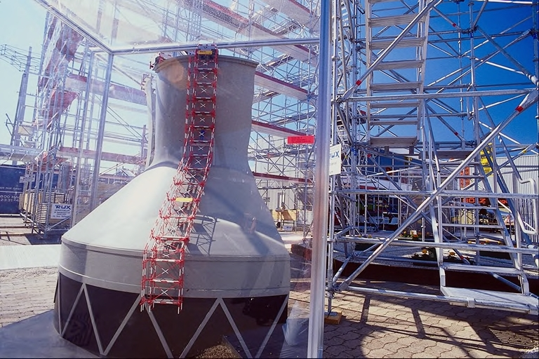

Adapted from Whoever (2000)

Figure 6‑1 Example of how a figure should be incorporated into the text

### Example of third-tier subheading

First paragraph.

Second paragraph.

Add paragraphs as needed.

### Another third-tier subheading

Add content here.

#### Fourth-tier subheading

Add content.

#### Anther fourth-tier subheading

Add content.

### Yet another third-tier subheading

Here is an example of how an equation should be incorporated in the text:

|  |  |  |  |
| --- | --- | --- | --- |
|  | | | Equation 2‑1 |
| where | *Ri* | is the raw score; | |
|  | *Rmin* | represents the minimum score; | |
|  | *Rmax* | is the maximum score; and | |
|  | *m* | is an arbitrary multiplier representing the upper standardized range value. | |

Another figure coming up.

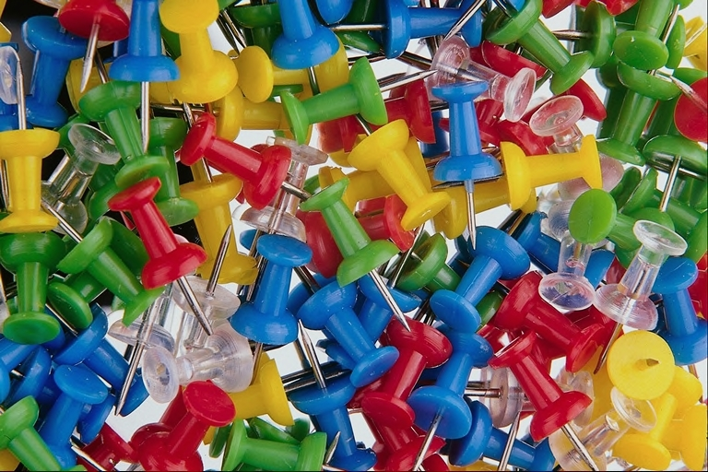

Figure 6‑2 Another figure

Here is an example of a table. Notice that if a table is split by a page break, rather place the table on the next page. Also notice the citation next to the table.

Table 2‑1 An example of a table

|  |  |
| --- | --- |
| **ID** | **Description** |
| 1 | Equal importance |
| 3 | Moderate importance |
| 5 | Strong or essential importance |
| 7 | Very strong or demonstrated importance |
| 9 | Extreme importance |
| 2, 4, 6, 8 | Intermediate values |
| Reciprocals | Inverse comparison  Source Saaty & Vargas (1991) |

If there is no space next to a table, then add the reference below the table.

Table 2‑2 Another table with citation positioned below the table

|  |  |  |  |  |  |
| --- | --- | --- | --- | --- | --- |
|  | Effective soil depth | Soil acidity | Slope gradient | Slope aspect | Priorities (%) |
| Effective soil depth | **1** | **2** | **3** | **3** | 44 |
| Soil acidity | **1/2** | **1** | **3** | **3** | 31 |
| Slope gradient | **1/3** | **1/3** | **1** | **1/2** | 10 |
| Slope aspect | **1/3** | **1/3** | **2** | **1** | 15 |

Saaty & Vargas (1991)

See guidelines for more instructions on referencing tables and figures.

Never end your section with a table or figure.

## TIMELINE

It is important to schedule your research to make sure you meet the deadlines. Include here a Gantt chart that lists the research activities and when each will be completed. Also include important milestones (such as submission dates). The timeline can be part of the methods section or it can be a separate section.

## FINANCIAL PLANNING

You may need to incur expenses during your research and it is always good to plan ahead. In this section you should think about what expenses will likely be incurred and where the funding will come from. For instance, you might have to visit your study area or you might need data that are not feely available. Explain here how much it will cost (more or less) and how you will pay for it. Include these details even if you will be paying for it yourself.

# LINKAGES OF STUDY TO DEPARTEMENTAL PROGRAMMES

Try to show that your study is part of a larger programme and indicate (where possible) how it relates to other (past, present or future) research in the department. This is especially important at MSc/PhD level, because such research projects often require specialized supervision, data and/or equipment. Or perhaps your research project forms part of a larger project. By referring to existing research projects/programmes you show that you understand the “bigger picture” and demonstrate that you are aware that you are part of a research team.

REFERENCES

Add your reference list here.

You can use Mendeley to create a reference list automatically. Refer the departmental guidelines.

Cone JD & Foster SL 1993. *Dissertations and theses from start to finish: Psychology and related fields.* Washington DC: American Psychological Association. Fifteen chapters ranging from ‘What are dissertations and theses?’ to ‘Presenting your project to the world’. Chapter 8 is intriguingly titled ‘Methodology (or, How you’re gonna do what you’re gonna do!)’.

Mouton J 2001. *How to succeed in your master’s and doctoral studies – A South African guide and resource book*. Pretoria: Van Schaik.

Paltridge B & Starfield S 2007. *Thesis and dissertation writing in a second language: A handbook for supervisors.* London: Routledge. Thirteen chapters cover topics such as: ‘Writing a research proposal’, ‘Writing an introduction’, ‘Writing the methodology’, ‘Writing the results chapter’, ‘Writing the discussions and conclusion’. A sample research proposal is appended.

Saaty TL & Vargas LG 1991. *Prediction, projection and forcasting.* Boston: Kluwer Academic Publishers.

1. <https://www.uwc.ac.za/Students/Postgraduate/Documents/Research_and_Design_I.pdf>
2. <http://research-methodology.net/research-philosophy/positivism/>